Amazon ECS Deployment Documentation
Introduction
This comprehensive documentation serves as a detailed guide for deploying applications using Amazon ECS (Elastic Container Service) with Fargate as the compute type. The deployment process involves setting up an ECS cluster, defining tasks, creating a load balancer, and managing services. By following the steps outlined in this documentation, you will be able to successfully deploy and scale your containerized applications on the AWS cloud infrastructure.
A cluster in ECS represents the underlying resources where your containers will run, typically a collection of EC2 virtual machines. When using the EC2 launch type, ECS is responsible only for deploying your containers, while you are responsible for managing the EC2 instances.
To prepare these instances, you need to install Docker to run containers and the ECS agent to allow communication with the ECS control plane. Additionally, you must perform routine server maintenance tasks, such as setting up firewalls to restrict access, applying updates, and patching vulnerabilities to ensure security.
With the EC2 launch type, you have full control over the infrastructure. You can configure and manage your EC2 instances as needed, but you are also responsible for all administrative tasks. ECS simplifies container management by deploying them to the EC2 instances, while you handle everything related to the servers themselves.
- ECS Clusters:
  - Logical groupings of EC2 instances, AWS Fargate containers, and other resources where containerized applications are deployed.
- Container Instances:
  - EC2 instances or AWS Fargate containers within a cluster that host containers and are registered with ECS.
- Task Definitions:
  - Blueprints specifying parameters for containers, including Docker image, CPU, memory, and network settings.
- Tasks:
  - Instantiation of a task definition, representing the execution of containers on a container instance within the ECS cluster.
- Services:
  - Manage continuous running and scaling of tasks, ensuring desired task count, and handling lifecycle management.
- Elastic Load Balancing (ELB):
  - Distributes incoming traffic across multiple containers within an ECS service for high availability and efficiency.
- Amazon ECR (Elastic Container Registry):
  - Fully-managed Docker container registry integrated with ECS for secure storage, management, and deployment of container images.
- Container Image:
  - A lightweight, standalone, executable package that includes everything needed to run a piece of software. Managed and stored in registries like Amazon ECR.
- VPC (Virtual Private Cloud):
  - A logically isolated section of the AWS Cloud where ECS clusters and other AWS resources operate, providing control over the network environment.
- AWS Fargate:
  - A serverless compute engine for containers that abstracts away infrastructure management, allowing for simplified deployment and operation of containers.

Prerequisites
Before initiating the deployment process, ensure that the following prerequisites are met:
- Properly configured AWS CLI with appropriate credentials
- Installation of Node.js on the local machine for application development
- Docker installed on the local machine for containerization
- A Git repository containing the application code and Dockerfile for building the Docker image

Step#1:Create provider.tf file
provider "aws" {
profile = "default"
region = "us-east-1"
}

Step#2 create terraform.tf file
module "ecrRepo" {
source = "./modules/ecr"

ecr_repo_name = local.ecr_repo_name

}
module "ecsCluster" {
source = "./modules/ecs"

demo_app_cluster_name = local.demo_app_cluster_name
availability_zones = local.availability_zones

demo_app_task_famliy = local.demo_app_task_famliy
ecr_repo_url = module.ecrRepo.repository_url
container_port = local.container_port
demo_app_task_name = local.demo_app_task_name
ecs_task_execution_role_name = local.ecs_task_execution_role_name

application_load_balancer_name = local.application_load_balancer_name
target_group_name = local.target_group_name
demo_app_service_name = local.demo_app_service_name
}

Step#3: create loacls.tf file
locals {
table_name = "alifa-table"

ecr_repo_name = "demo-app-ecr-repo"

demo_app_cluster_name = "demo-app-cluster"
availability_zones = ["us-east-1a", "us-east-1b", "us-east-1c"]
demo_app_task_famliy = "demo-app-task"
container_port = 3000
demo_app_task_name = "demo-app-task"
ecs_task_execution_role_name = "demo-app-task-execution-role"

application_load_balancer_name = "cc-demo-app-alb"
target_group_name = "cc-demo-alb-tg"

demo_app_service_name = "cc-demo-app-service"
}

Step#4: Make a module folder and make ecr.tf file in it

• aws_s3_bucket resource:
- Creates an S3 bucket for storing Terraform state.
- The bucket name is dynamically provided by a variable (var.bucket_name).
- force_destroy = true ensures that the bucket and its contents are deleted when the resource is destroyed.
• aws_s3_bucket_versioning resource:
- Enables versioning for the S3 bucket to retain previous versions of objects. This helps in recovering from accidental deletions or overwrites.
• aws_s3_bucket_server_side_encryption_configuration resource:
- Configures server-side encryption using AES256 for objects stored in the bucket to enhance data security.
• aws_dynamodb_table resource:
- Creates a DynamoDB table to manage Terraform state locks, preventing multiple concurrent Terraform executions.
- The table has a single attribute, LockID, which acts as the primary key.
- billing_mode is set to "PAY_PER_REQUEST", meaning costs are based on the number of read/write operations.
- variable "bucket_name":
  - Defines a variable for the S3 bucket name.
  - Includes a validation rule to ensure the bucket name adheres to S3 naming conventions:
    - Can contain only lowercase letters, numbers, and hyphens.
    - Must start and end with a lowercase letter or number.
    - Length must be between 3 and 63 characters.
  - Provides a clear error message if the validation fails.
- variable "table_name":
  - Defines a variable for the DynamoDB table name.
  - No additional validations are specified, but the name is described as the remote DynamoDB table name.
- resource "aws_dynamodb_table" "terraform_locks":
  - This defines a DynamoDB table resource named terraform_locks.
- name = var.table_name:
  - The name of the DynamoDB table is dynamically provided using a variable (var.table_name). This makes the table name configurable.
- billing_mode = "PAY_PER_REQUEST":
  - The billing mode is set to "PAY_PER_REQUEST," meaning costs are incurred based on the number of read and write requests rather than a fixed capacity.
  - This mode is cost-effective for applications with unpredictable or low traffic.
- hash_key = "LockID":
  - Specifies the primary key for the table. The primary key is a single attribute named LockID.
  - This key is used to uniquely identify each item in the table.
- attribute { ... }:
  - Defines the schema for the LockID attribute:
    - name = "LockID": Names the attribute.
    - type = "S": Specifies the data type as a string (S).

Purpose of the Table
- The DynamoDB table is primarily used by Terraform to store lock information.
- When Terraform operations are running, a lock is created in this table to prevent other operations from modifying the state simultaneously.
- Once the operation is complete, the lock is removed.

Git cloned the app file intop the repo.
There is the app we want to deploy and also a dockerfile to build our image and push it in the repo of ecr
This Dockerfile:
- Creates a minimal Node.js environment with Alpine Linux.
- Installs dependencies from package.json.
- Copies the app source code.
- Exposes port 3000 for the application.
- Launches the app by running server.js.

Downloaded nodejs.
Then in ubuntu installed docker and aws cli was configured.
curl "https://awscli.amazonaws.com/awscli-exe-linux-x86_64.zip" -o "awscliv2.zip"
unzip awscliv2.zip
sudo ./aws/install
Cloned my repo there and then changed the directory to app. There is a dockerfile where it will

Docker image commands to push it in the ecr.

Use the following steps to authenticate and push an image to your repository. For additional registry authentication methods, including the Amazon ECR credential helper, see Registry authentication .
- Retrieve an authentication token and authenticate your Docker client to your registry. Use the AWS CLI:
aws ecr get-login-password --region us-east-1 | docker login --username AWS --password-stdin 072262450408.dkr.ecr.us-east-1.amazonaws.com
Note: if you receive an error using the AWS CLI, make sure that you have the latest version of the AWS CLI and Docker installed.
- Build your Docker image using the following command. For information on building a Docker file from scratch, see the instructions here . You can skip this step if your image has already been built:
docker build -t demo-app-ecr-repo .
- After the build is completed, tag your image so you can push the image to this repository:
docker tag demo-app-ecr-repo:latest 072262450408.dkr.ecr.us-east-1.amazonaws.com/demo-app-ecr-repo:latest
- Run the following command to push this image to your newly created AWS repository:
docker push 072262450408.dkr.ecr.us-east-1.amazonaws.com/demo-app-ecr-repo:latest
can see the build image in ecr.

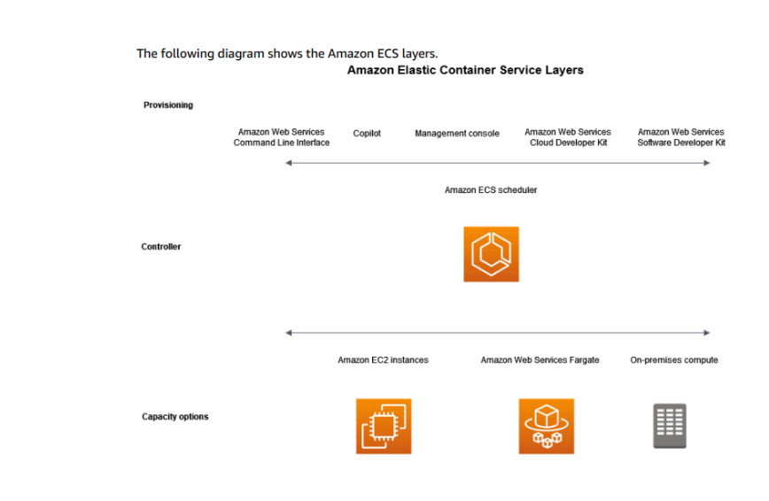
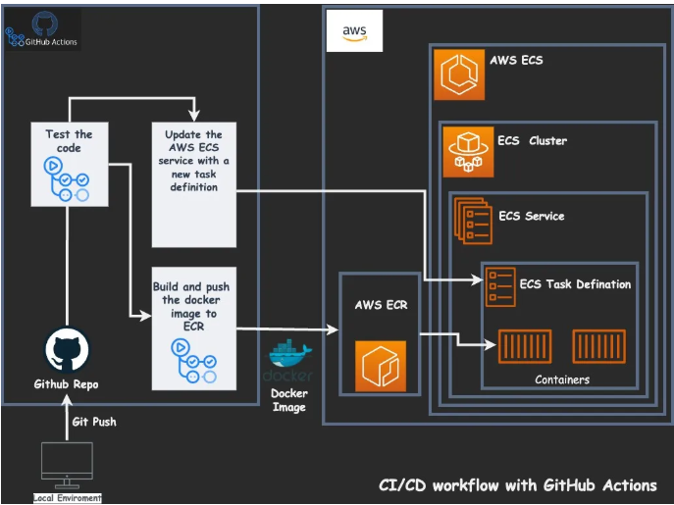

Now in modules make ecs folder and then ecs.tf
# Define an ECS cluster named with a variable value for managing tasks and services.
resource "aws_ecs_cluster" "demo_app_cluster" {
name = var.demo_app_cluster_name
}

# Create a default VPC, automatically provisioned by AWS.
resource "aws_default_vpc" "default_vpc" {}

# Define a default subnet in the first availability zone.
resource "aws_default_subnet" "default_subnet_a" {
availability_zone = var.availability_zones[0]
}

# Define a default subnet in the second availability zone.
resource "aws_default_subnet" "default_subnet_b" {
availability_zone = var.availability_zones[1]
}

# Define a default subnet in the third availability zone.
resource "aws_default_subnet" "default_subnet_c" {
availability_zone = var.availability_zones[2]
}

# Define an ECS task with container specifications and Fargate as the compute type.
resource "aws_ecs_task_definition" "demo_app_task" {
family = var.demo_app_task_famliy # Task family name.
container_definitions = <<DEFINITION # Container setup for the application.
[
{
"name": "${var.demo_app_task_name}", # Container name.
"image": "${var.ecr_repo_url}", # Image location in ECR.
"essential": true, # Marks container as critical.
"portMappings": [ # Maps container and host ports.
{
"containerPort": ${var.container_port},
"hostPort": ${var.container_port}
}
],
"memory": 512, # Memory allocation.
"cpu": 256 # CPU units allocated.
}
]
DEFINITION
requires_compatibilities = ["FARGATE"] # Indicates Fargate compatibility.
network_mode = "awsvpc" # Enables networking.
memory = 512
cpu = 256
execution_role_arn = aws_iam_role.ecs_task_execution_role.arn # IAM role for execution.
}

# Define an IAM role for ECS tasks to interact with AWS services securely.
resource "aws_iam_role" "ecs_task_execution_role" {
name = var.ecs_task_execution_role_name
assume_role_policy = data.aws_iam_policy_document.assume_role_policy.json
}

# Attach the Amazon ECS Task Execution Role policy to the IAM role.
resource "aws_iam_role_policy_attachment" "ecs_task_execution_role_policy" {
role = aws_iam_role.ecs_task_execution_role.name
policy_arn = "arn:aws:iam::aws:policy/service-role/AmazonECSTaskExecutionRolePolicy"
}

# Create an application load balancer to distribute traffic.
resource "aws_alb" "application_load_balancer" {
name = var.application_load_balancer_name
load_balancer_type = "application"
subnets = [ # Assign ALB to default subnets.
"${aws_default_subnet.default_subnet_a.id}",
"${aws_default_subnet.default_subnet_b.id}",
"${aws_default_subnet.default_subnet_c.id}"
]
security_groups = ["${aws_security_group.load_balancer_security_group.id}"] # Assign security group.
}

# Define a security group for the load balancer to allow inbound and outbound traffic.
resource "aws_security_group" "load_balancer_security_group" {
ingress { # Allow HTTP inbound traffic.
from_port = 80
to_port = 80
protocol = "tcp"
cidr_blocks = ["0.0.0.0/0"] # Open to all.
}

egress { # Allow all outbound traffic.
from_port = 0
to_port = 0
protocol = "-1"
cidr_blocks = ["0.0.0.0/0"]
}
}

# Create a target group for the load balancer to route traffic to ECS tasks.
resource "aws_lb_target_group" "target_group" {
name = var.target_group_name
port = var.container_port
protocol = "HTTP"
target_type = "ip" # Targets ECS task IPs.
vpc_id = aws_default_vpc.default_vpc.id
}

# Configure the load balancer to listen on port 80 and forward traffic to the target group.
resource "aws_lb_listener" "listener" {
load_balancer_arn = aws_alb.application_load_balancer.arn
port = "80"
protocol = "HTTP"
default_action {
type = "forward"
target_group_arn = aws_lb_target_group.target_group.arn
}
}

# Define an ECS service to manage and run ECS tasks with Fargate launch type.
resource "aws_ecs_service" "demo_app_service" {
name = var.demo_app_service_name
cluster = aws_ecs_cluster.demo_app_cluster.id
task_definition = aws_ecs_task_definition.demo_app_task.arn
launch_type = "FARGATE"
desired_count = 1 # Specifies how many tasks to run.

load_balancer { # Attach load balancer to the ECS service.
target_group_arn = aws_lb_target_group.target_group.arn
container_name = aws_ecs_task_definition.demo_app_task.family
container_port = var.container_port
}

network_configuration { # Define networking setup.
subnets = ["${aws_default_subnet.default_subnet_a.id}", "${aws_default_subnet.default_subnet_b.id}", "${aws_default_subnet.default_subnet_c.id}"]
assign_public_ip = true # Assign a public IP for tasks.
security_groups = ["${aws_security_group.service_security_group.id}"] # Security group for tasks.
}
}

# Define a security group for the ECS service, allowing communication from the ALB.
resource "aws_security_group" "service_security_group" {
ingress { # Allow inbound traffic from the load balancer.
from_port = 0
to_port = 0
protocol = "-1" # Allow all protocols.
security_groups = ["${aws_security_group.load_balancer_security_group.id}"]
}

egress { # Allow all outbound traffic.
from_port = 0
to_port = 0
protocol = "-1"
cidr_blocks = ["0.0.0.0/0"]
}
}

